CSE-4807
STRATEGIC MANAGEMENT CASE STUDY ASSIGNMENT
Strategic Challenges in Managing a Fast-Growing
Cloud Computing and Cybersecurity Solutions Company
for Global Clients
A Business Case Study of Intelligent Machines
Cloud & Security Solutions Division (IM-CSS), Banani, Dhaka
Submitted by
Mehreen Hossain Chowdhury
Student ID: 210041219
Section: 2
Submitted to
Tanjila Alam Sathi
Department of Computer Science and Engineering
Islamic University of Technology

Date of Submission: 25 August 2026

Table of Contents
1. Introduction 2
1.1 Research Method and Data 2
2. Overview of the Company 3
3. Individual Case Studies 4
3.1 Case Study 1: Shortage of Skilled Cybersecurity and Cloud Professionals 4
3.2 Case Study 2: Difficulty Managing Global Cybersecurity Threats 8
3.3 Case Study 3: Weak Online Presence and Brand Recognition 11
3.4 Case Study 4: Increasing Operational Costs and Budget Management Problems 15
3.5 Case Study 5: Poor Client Communication and Service Reporting 19
3.6 Case Study 6: Data Privacy and Compliance Risks 22
3.7 Case Study 7: Inefficient Collaboration in Remote IT Teams 26
3.8 Case Study 8: Challenges in Scaling Infrastructure and Business Operations 29
4. Strategic Recommendations Summary 33
5. Conclusion 35
6. References 35

1. Introduction
Intelligent Machines Ltd. is a technology company based in Dhaka and headquartered in Banani. It is best known for its work in artificial intelligence and digital transformation for large regional clients such as bKash and Unilever Bangladesh. From there, the company formed a separate growth division, Intelligent Machines Cloud and Security Solutions (IM-CSS, as referenced throughout this report), to extend the portfolio into cloud infrastructure management and cybersecurity consulting for global clients. The division sells cloud migration, cloud infrastructure management, network security, data backup and recovery, security monitoring and managed IT services and now works with ten clients in Bangladesh, Singapore, Australia and the UAE.
This growth forms the basis for nearly everything in this report. IM-CSS deliberately kept its administrative overhead lean during its first two years and prioritised technical hires instead, a decision the division's Senior Technical Lead described in interview as the right call early on but one that is starting to show its limits as the team takes on bigger accounts. The arrangements that carried the division through those first two years were largely informal. Incidents were handled by whoever was available, client updates were sent when someone had a spare moment, and new client environments were built by hand by the same small group of senior engineers. Those arrangements worked at a small client count. At nineteen people, ten clients and four time zones they have begun to fail in ways that show up as budget overruns, slow incident response, and tenders that stall before a technical conversation ever takes place.
This report treats each of the eight challenges as a separate business case rather than as a general discussion of divisional problems. The structure follows the description of a project business case in Section 1.2.6.1 of the PMBOK Guide, which presents it as a documented feasibility study that establishes the validity of the benefits of a proposed course of action and provides the basis for authorising further work (Project Management Institute, 2021). In that sense a business case must state the business need, analyze the situation that created it, recommend a course of action and define how the outcome will be judged. The five headings required in this assignment follow this sequence exactly, with the implementation plan falling between the recommendation and the evaluation.
Each recommendation comes from a known framework rather than an opinion. The security cases are built upon the NIST Cybersecurity Framework 2.0 and ISO/IEC 27001:2022 (NIST, 2024; ISO/IEC, 2022). The AWS Well-Architected Framework and the FinOps Foundation operating model are used for cost and infrastructure cases (Amazon Web Services, 2024a; FinOps Foundation, 2025). The service management cases are representative of ITIL 4 incident management practice (Axelos, 2019). Published documentation from Amazon Web Services, Microsoft, Cisco and Cloudflare is used at various points to demonstrate how a much larger organisation solved a comparable problem, on the understanding that a nineteen-person division can borrow the principle without being able to copy the scale. Where a framework is named in a recommendation, the citation marks the boundary between what the source says and what this report proposes for IM-CSS.

1.1 Research Method and Data
The results reported here are based on primary field research. I, a Junior AI Engineer at Intelligent Machines Ltd, interviewed Sifat Ibna Amin, Senior Technical Lead of IM-CSS, in a structured manner in August 2026. The interview covered staffing and retention, security operations, marketing and client acquisition, cost structure, client communication, compliance posture, remote collaboration and infrastructure scaling and was designed to generate quantitative baselines where the division had the relevant data as opposed to general impressions. A small amount of observational material also comes from my own work inside the company. Where it is used it is flagged in the text and kept apart from what the Technical Lead reported, since one is a management view of the division and the other is a junior engineer's view of a working week. Neither stands in for the other.
Each of the case studies below therefore begins with a table of field research data that reports what was actually reported. If a figure was given as a range the range is kept instead of averaged and if the division doesn't currently measure something the table explicitly states so instead of substituting an estimate. The last category is a finding in itself, as several of the eight challenges were found to be partly caused by lack of measurement rather than a poor result.
Comparative material used in the recommendations comes from vendor documentation and published framework guidance, all of which is listed in Section 6. Presenting the baseline before the analysis is deliberate. A recommendation is only defensible if the situation it responds to has been measured first, and the same reported figures are reused in the evaluation section so that success can be judged against a number that existed before the intervention rather than against an impression formed afterwards.

2. Overview of the Company
IM-CSS occupies a distinct but adjacent position to its parent company. Where Intelligent Machines' core business is artificial intelligence products and consulting for regional enterprises, IM-CSS sells cloud operations and security capability to organisations that need it but do not want to build an in-house team for it. That is a segment which has grown quickly for Bangladeshi suppliers over the past five years, because small and medium enterprises in Singapore, the Gulf and Australia increasingly buy this capability as a service, and they are willing to buy it from South Asia when the technical quality is credible.
Table 1: Company profile, August 2026
Item | Detail
Division | Intelligent Machines Cloud and Security Solutions (IM-CSS)
Parent company | Intelligent Machines Ltd., an AI and digital transformation company
Head office | Banani, Dhaka, Bangladesh
Total employees | 19 in total: 13 technical, 6 administrative
Remote work share | Approximately 85 per cent remote, with a small core team in the Banani office
Active clients | 10, across Bangladesh, Singapore, Australia and the United Arab Emirates
Primary services | Cloud migration, cloud infrastructure management, network security, security monitoring, data backup and recovery, managed IT services
Regional context | Parent company relationships include bKash and Unilever Bangladesh, which supports credibility in the domestic market while IM-CSS builds its own international client base
Interview source | Sifat Ibna Amin, Senior Technical Lead, IM-CSS, August 2026
The technical delivery is the part of the division that has held up best under growth. Ten clients retained across four countries, with roughly two thirds of new business arriving through referral, is not the profile of a team whose engineering is in question. Renewal and referral conversations rarely turn on whether the work was sound.
The structure around that delivery is where the strain sits. With thirteen technical and six administrative staff, and with the administrative function deliberately kept lean during the first two years, almost everything a larger competitor would handle through a specialist role is handled at IM-CSS by someone doing it in addition to their main job. There is no dedicated marketing function, no compliance officer, no financial planning role, and no security operations team separate from the engineers delivering client projects. This is the structural fact behind most of the eight challenges. The division did not run out of engineering capability. It ran out of management capacity, and it did so at the point where the client base became large enough and geographically spread enough that informal coordination stopped working.
The eight case studies that follow describe eight specific expressions of that single underlying condition, and the strategic summary in Section 4 returns to how they connect and in what order they should be addressed.

3. Individual Case Studies
The eight case studies below use the same five components required by the assignment: business needs, analysis of the situation, recommendation, implementation plan and evaluation. Each one opens with a table of baseline figures so that the analysis is anchored to measured facts and so that the evaluation section has something concrete to measure against. Timelines are expressed in weeks, months or quarters from the start of the programme rather than as calendar dates, since the sequencing in Section 4 assumes the work does not all begin at once.

3.1 Case Study 1: Shortage of Skilled Cybersecurity and Cloud Professionals

Business Needs
The need for a consistent pool of qualified cloud engineers, cybersecurity experts and DevOps professionals means that IM-CSS will have to continue to develop a workforce that meets its quality standards, while also meeting customer demand and maintaining on-time delivery as customer base expands.
To do this, four critical factors are required:
(1) a competitive compensation package that is based upon the remote/online job market, and not solely the local job market. This is necessary due to the fact that all engineers located in Dhaka with cloud experience today are competing for jobs in an international marketplace regardless of whether IM-CSS wishes to recognize it.
(2) Funding must be made available for education/training/certification programs within the division. As such, these junior employees will be able to transition into client ready specialists within their own organization, rather than having to hire these individuals at the senior level from outside organizations.
(3) An established career development track. Although many people believe that high levels of turnover occur primarily due to lack of adequate compensation, at least as significant a factor contributing to this trend, is the lack of a clear "next-step" to advance professionally.
(4) Establishing sufficient documentation and shared responsibility among team members. Should any member(s) of the senior engineering staff resign, there is a reasonable chance that the technical delivery of projects could stall, especially considering that currently, there are only 13 engineers at the technical leadership level within the division.

Analysis of the Situation
Table 2: Case Study 1 baseline, twelve months to 31 July 2026
Indicator | Recorded position
Average technical hiring time | Approximately 3 weeks
Open technical vacancies | 1
Annual technical turnover | Approximately 15 per cent
Hardest role to recruit | Senior Cloud Security Architect
Main recruitment obstacle | Higher salaries and remote-work flexibility offered by multinational firms
Technical headcount | 13 of 19 total staff
Training and certification budget | Not allocated as a separate line

Put the 15 per cent annual turnover in context of a technical headcount of thirteen and the figure ceases to look so moderate. It amounts to about two people a year. Given there was but one open vacancy at interview, the division has very little room to manoeuvre. Should a senior member leave at an inopportune time, delivery capacity on multiple accounts will be put at risk with no bench to make up for it. That is what separates turnover as a mere statistic from an operational hazard. The same percentage carries a different weight with a dozen or so staff than it does with a hundred.
Then there are two issues under the compensation gap that the division could address. For one, the absence of a dedicated budget for training and certification puts a cap on what can be put before security-minded international clients and stymies the internal development of junior engineers. There is also no formal progression structure on the books. That is a problem when an employer is not able to compete on salary and must rely on visible growth to hold on to talent. An engineer who does not know what is needed for the next step will seek that kind of clarity elsewhere. In today’s remote market they need not go far from Dhaka to get it.
The business consequences are threefold. You see more delivery risk as work is funneled to the handful capable of doing it. Service quality is apt to be inconsistent if less seasoned staff have to fill in without oversight. And the division hits a ceiling on the volume of new client work it can take on in any given period, a hard limit on concurrent projects detailed in Case Study 8. The outside environment ensures these are structural problems, not ones that will pass. The 2025 ISC2 Cybersecurity Workforce Study, drawn from a record 16,029 respondents, stopped publishing a single global headcount gap figure altogether, on the grounds that participants in 2024 and 2025 had both ranked the shortage of specific critical skills above the shortage of people (ISC2, 2025). That shift is worth noticing, because it describes the IM-CSS position more accurately than a headcount figure would. In the same study, 88 per cent of respondents reported at least one significant security event that they attributed to a skills shortage, and 33 per cent said their organisation lacked the resources to staff its team adequately (ISC2, 2025). This is the ordinary condition of the market, then, and the organisations that cope with it are those that build their own talent rather than competing for a scarce pool of ready-made hires.
My own position inside the company gives a view of the same dependency from below. As a Junior AI Engineer at Intelligent Machines, I have found that a good deal of what I needed during onboarding and in ordinary technical work came from asking an experienced colleague directly. Which system behaves in which way, what the project conventions are, how a particular class of issue has been handled before. The team is accessible and the answers are good, so the arrangement works. It works while those people are free to answer. When they are busy the work slows, and it slows for a reason that has nothing to do with the difficulty of the task. The information sits in somebody's head instead of in a document. So the recommendations here on documentation, ownership and structured handover do not rest on management-level interview data alone. They match what the division looks like from a junior seat.

Recommendation
It is recommended to see this as a talent development issue and not as a recruitment problem, with four measures that support each other. Figure 1 shows how they fit together.
First, develop a technical career path from Junior Engineer to Engineer to Senior Engineer to Cloud or Security Architect with published criteria for making the leap from one level to the next including technical scope, client-facing responsibility and certification at each level. Progression reviews should be held twice a year on fixed dates. It is not the ceremony that counts, it is the visibility, and this is the cheapest intervention on the list.

Second, subsidize and track certifications that are relevant to client work. The natural set provided the service lines of the division are AWS Certified Solutions Architect, Microsoft Azure Administrator and Security Engineer, Cisco CCNA Security and CompTIA Security Plus. It does two things at once. Capability and retention improve internally, and credibility improves externally, because the partner tiers of the major providers are graded partly on certified headcount. The AWS Services Partner published requirements make this concrete: the entry Select tier asks for four accredited individuals, two AWS Foundational Certified Individuals and two AWS Technical Certified Individuals, alongside three launched opportunities (Amazon Web Services, n.d.a). Against thirteen technical staff those are reachable numbers, not aspirational ones. The same spending therefore also supports the partner status discussed in Case Study 3, which is useful sequencing for a division on a limited budget.

Third, build a junior bench through an internship-to-hire pipeline with local universities such as BUET, IUT, NSU or BRAC. This reduces the total dependence on senior lateral hires, the slowest and most expensive to acquire, and gives the division a way to grow its own Cloud Security Architect over two or three years rather than failing again and again to hire one.
Fourth, use retention incentives targeted at the roles most vulnerable to multinational offers. Because IM-CSS can’t close the salary gap all by itself, the gap should be closed with things that cost less than base pay: a bonus tied to project and renewal outcomes, genuinely flexible remote arrangements and a long-service incentive for senior technical staff. Pay bands should also be benchmarked against remote-friendly employers hiring in Bangladesh at least twice a year and published internally, since opacity around pay is itself a source of dissatisfaction.
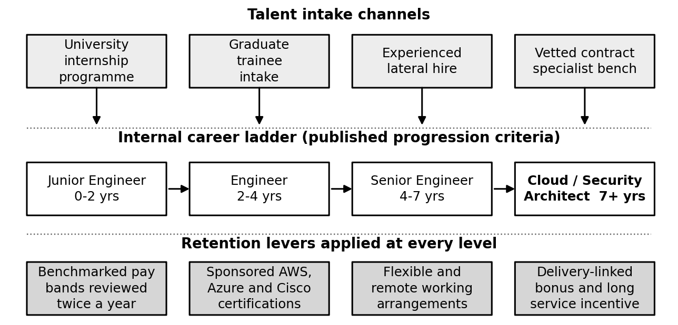
Figure 1: Talent intake channels, career ladder and retention levers

Implementation Plan
Table 3: Case Study 1 implementation plan
Action | Responsible | Timeline | Resources and technology
Design the career ladder and publish progression criteria | HR Lead and Division Head | 0 to 30 days | Internal policy document, skills matrix
Launch the certification subsidy programme | Sifat Ibna Amin (Technical Lead) | 0 to 30 days | AWS, Azure and Cisco training budget, exam vouchers
Benchmark pay bands against remote-friendly employers | Division Head and HR Lead | 0 to 60 days | Salary survey data, revised compensation policy
Partner with one or two universities for an internship pipeline | Division Head and HR Lead | 30 to 90 days | Memorandum of understanding, intern stipend budget
Introduce documented handover and pairing on senior tasks | Technical Lead | 30 to 90 days, then continuous | Internal wiki, review checklist
Roll out the retention incentive structure | Division Head | 90 days and beyond | Revised compensation policy, bonus criteria
Recruit the first graduate trainee cohort | HR Lead | Quarter 2 | Structured onboarding programme, assigned mentors

Evaluation
What needs to be measured here is stability and predictability, not headcount. A division this size can perform flawlessly while it is small. What it cannot do is perform well while nobody knows who will remain in six months. So, technical staff turnover and hiring time are the two headline numbers, and both deserve the division head's monthly attention rather than an annual review that comes too late.
Certification count needs a separate line because it acts early. It shifts even before the turnover does, it takes about a minute to verify, and it feeds directly into the partner-tier applications in Case Study 3. One measurement, two functions. The indicators not to be measured matter equally. In those cases, the deliverable #1 is just the baseline.
Table 4: Case Study 1 key performance indicators
Indicator | Current baseline | Target
Annual technical turnover | Approximately 15 per cent | Below 10 per cent
Average technical hiring time | Approximately 3 weeks | Under 2 weeks for standard roles
Technical staff holding at least one relevant certification | Not currently tracked | 70 per cent of technical staff within 18 months
Project delays attributable to staffing gaps | Not currently tracked | Tracked from month 1, reducing quarter on quarter
Internship placements converted to full-time technical staff | Not applicable | At least 50 per cent of each cohort
Senior-level tasks with a documented second owner | Not tracked | 100 per cent within 6 months

3.2 Case Study 2: Difficulty Managing Global Cybersecurity Threats

Business Needs
Security monitoring is what IM-CSS sells. This distinction matters as detection and response here are not a back office operation that helps keep the lights on inside the company, it is the product the client pays for. The division, therefore, needs the coverage of security monitoring, detection and response, which will be able to correlate multiple client environments and multiple jurisdictions at once and which will include threat intelligence to avoid limiting itself to its own sensors only.
There are three conclusions that follow from that. First, there has to be one centralised location where the activity of all ten environments is correlated, because the indicator, which appears to be meaningless inside a single environment, may turn out to be highly meaningful when it appears in three different environments at once. Second, there has to be a documented incident response procedure with clear severity levels, rehearsed rather than filed, because the classification of an incident should not depend on who happens to be on duty. And third, the coverage model has to take into account the working hours of clients, because once the Australia and the UAE are included into the portfolio, the coverage model becomes wider than just one Dhaka working day.

Analysis of the Situation
Table 5: Case Study 2 baseline, twelve months to 31 July 2026
Indicator | Recorded position
Security alerts per day | Approximately 25 to 35
Alerts requiring human investigation | Approximately 3 to 5 per day
Serious incidents per month | 8 to 10
Most common attack type | Phishing attempts and unauthorised login or credential-stuffing attempts
Average response time once an alert is flagged | Approximately 45 to 60 minutes
Client environments monitored | 10, across four countries
Dedicated security operations staff | None; monitoring is handled by technical staff alongside delivery work

Start with the ratio of alert to investigation. About one out of seven or eight alerts are escalated to a person, which tells of the monitoring system that works but has not been tuned. Either the detection thresholds are too wide and produce lots of noise or there is no triage layer catching the false positives before an analyst sees them. Both ways the reason is the same. Tuning detection rules is nobody's responsibility, so it is not done. False alarms are costly too, and the cost is documented rather than merely intuitive. In the 2025 SANS Detection and Response Survey, 73 per cent of organisations named false positives as their single biggest detection challenge (Stamus Networks, 2025). The survey literature on security operations centres describes the downstream effect as alert fatigue, in which prolonged exposure to high volumes of low-value alerts desensitises analysts and degrades the quality of their triage decisions over time (Tariq et al., 2025). The real alert becomes less visible, not more.
The incidence volume is the more shocking figure. Eight to ten serious incidents a month across ten clients in four jurisdictions is a considerable workload, and it is being handled by thirteen technical staff, most of whom are not dedicated to security operations at all. The same engineers perform cloud migration and manage the infrastructure in addition. To put it straightforwardly, the division performs a security operations workload without a proper security operations function. The situation continues until two incidents appear during the cloud migration cutover period.
The 45 to 60 minutes' window of response is acceptable for most incidents but awkward against the standards of the market. The Technical Lead reported in interview that the overseas clients, especially the ones in finance and fintech in Singapore and Australia, look for acknowledgment inside thirty minutes, and that the division cannot make this commitment at the moment (S. I. Amin, personal communication, August 2026). The mean response time surely hides much worse tails, because any alert raised outside Dhaka working hours does not have any official way of reaching anybody.
All the above mentioned problems have the roots in design and not in lack of personnel. The clients are located in Bangladesh, Singapore, Australia and the United Arab Emirates, and the division deals with different threat patterns and compliance requirements, depending on the jurisdiction, without any common framework. Additional personnel will not help with that. This situation results in the lopsided reputation risks, because the security provider gains no reputation from the hundreds of incidents handled well and suffers immensely from the missed one on an international client overnight.

Recommendation
The recommendation is to replace the loosely coordinated monitoring process with the single correlated pipeline and the defined human escalation path. Figure 2 illustrates the suggested approach. Five actions are required, with the most valuable for money and immediate benefits mentioned first.
Start with implementing the SIEM solution, for which Microsoft Sentinel is the obvious choice, in order to correlate the logs of all ten client environments and reduce the alert noise through automated triage rules. Sentinel is a cloud-native SIEM with correlation, analytics rules and automated response built in, and it bills on data ingested rather than per seat (Microsoft, n.d.a). That billing model matters here. A division running ten environments with no dedicated analyst headcount pays for what it monitors, not for seats it does not have. The output of this step is not enhanced detection. It is a better signal-to-noise ratio. Suppression and enrichment provided in one centralised place eliminate a large part of the false positives currently appearing on the analyst's screen. Triaging should be assigned to the named analyst on the monthly basis because the only reason the current pipeline is untuned is the lack of ownership.
Second, subscribe to the threat intelligence feed, such as Cisco Talos, in order to operate ahead of the attack patterns and not react to whatever the division detects. Talos publishes indicators, reputation data and campaign research drawn from telemetry across Cisco's global customer base (Cisco Talos, n.d.). Phishing and credential stuffing attacks are prevalent in the confirmed incidents, and the campaigns of this type affect many companies simultaneously using shared infrastructure. The indications published by the research company, acting globally, will appear well before the attack will be launched against a ten-client portfolio in Dhaka.
Third, reduce the volume of automated attacks coming to the internal monitoring. The edge security layer in front of the client-facing infrastructure, including the web application firewall, DDoS mitigation and bot management will filter the attacks before they become alerts. Cloudflare is the solution to be considered, since it packages all three of those functions at the network edge (Cloudflare, n.d.). The choice is supported by the pattern in the confirmed incidents. The 2026 Verizon Data Breach Investigations Report, covering more than 31,000 security events, found the human element present in 62 per cent of breaches, which is the category phishing and credential stuffing both sit in (Verizon, 2026). Concerning the credential stuffing attacks, this step provides the single most effective action because it stops the attack and not detect it after it happened.
Fourth, implement the tiered on-call rotations among the technical staff. It makes the sub-30-minute acknowledgment commitment for critical alerts possible without having the round-the-clock dedicated security personnel the division cannot afford now. The on-call time has to be compensated, because it is the informal arrangement based on the personal goodwill that creates the inconsistence in the response in the first place.
And fifth, document the classification and escalation matrix of the incidents so that the severity will be determined consistently, not case by case. Case Study 5 depends on this one. You cannot commit to any communication cadence with the clients until you have the severity levels.
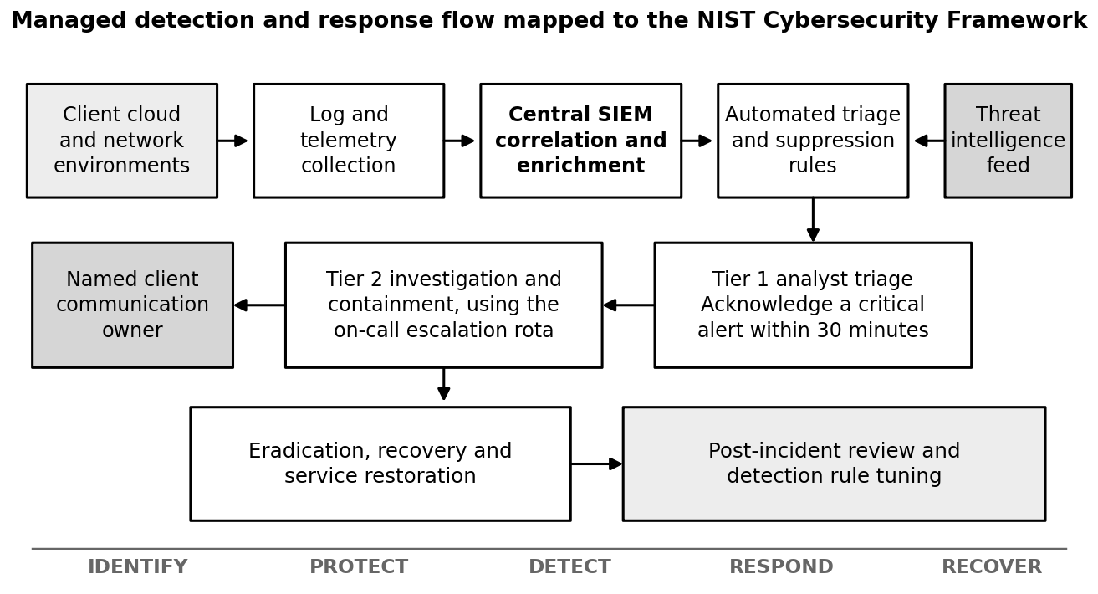
Figure 2: Detection and response flow mapped to the six functions of the NIST Cybersecurity Framework 2.0

Implementation Plan
Table 6: Case Study 2 implementation plan
Action | Responsible | Timeline | Resources and technology
Evaluate and deploy SIEM tooling, starting with the three largest clients | Sifat Ibna Amin (Technical Lead) | 0 to 30 days | Microsoft Sentinel trial, budget approval
Subscribe to a threat intelligence feed and integrate indicators | Technical Lead | 0 to 30 days | Cisco Talos or equivalent subscription
Document the incident classification and escalation matrix | Technical Lead | 0 to 30 days | Internal SOP, ITIL 4 incident management guidance
Migrate remaining client log sources into the platform | Security analysts | 30 to 90 days | Log connectors, agent deployment
Build a compensated tiered on-call rotation | Division Head and Technical Lead | 30 to 90 days | On-call tooling such as PagerDuty, revised policy
Deploy the edge security layer for client-facing services | Technical team | 30 to 90 days | Cloudflare Business or Enterprise tier
Review and retune alert thresholds under a named owner | Security analysts | 90 days and beyond, monthly | SIEM analytics, quarterly review cadence
Run two incident response rehearsals per year | Technical Lead | From month 6 | Tabletop exercise scenarios

Evaluation
The mean time to acknowledge is the commercial metric because it is the metric international clients include into their service agreements. Report it as the median and the 95th percentile, not as the average. The average of 45 to 60 minutes can hide a few alerts with hours-long response time, and they are the very ones damaging the reputation.
The ratio of actionable alerts to total alerts is the metric showing best of all how effective the tuning is. Improving it from about one in eight to better than one in three lets the analysts spend most of their time on productive work. That means better detection, and a considerably better job for a team the division already struggles to retain.
The incident count has to be seen as a trend and not as a goal. When the detected incidents rise immediately after the platform is deployed, it means that the detection is improved, not that the security is worse. Management has to be informed of this fact in advance so that the first quarterly report will be seen correctly.
Table 7: Case Study 2 key performance indicators
Indicator | Current baseline | Target
Mean time to acknowledge a critical alert | 45 to 60 minutes | Under 30 minutes
Mean time to resolve a confirmed incident | Not formally tracked | Baseline set in month 1, then reducing
Share of alerts requiring human investigation | Roughly 1 in 7 to 8 | Better than 1 in 3 after tuning
Client environments covered by the central platform | 0 of 10 | 10 of 10 within 90 days
Serious incidents per month | 8 to 10 | Tracked as a trend rather than as a target
Client-reported security satisfaction | Not measured | Baseline in quarter 1, improving each quarter

3.3 Case Study 3: Weak Online Presence and Brand Recognition

Business Needs
The division needs a way of acquiring new clients that will be independent from the personal contacts the division and its parent company have. In practice, it means the need for better online visibility, search presence constructed according to the actual services offered and the publication of client outcomes in the form readable without asking a referral first.
The division also needs validation which it cannot give to itself. The partner status in the AWS or Microsoft programmes carries weight in the international procurement processes precisely because somebody else issues it and it requires proof. In addition, the division needs the mechanism of transforming the finished projects into the publication. There are just two case studies against ten active clients, and the reason is not the absence of interesting engagement among the other eight. It is the absence of the task in the division's agenda.

Analysis of the Situation
Table 8: Case Study 3 baseline, twelve months to 31 July 2026
Indicator | Recorded position
New client channel breakdown | Approximately 65 to 70 per cent referrals, 15 to 20 per cent website and inbound, remainder direct outreach
Published case studies | 2, against 10 active clients
Client testimonials | Remaining client feedback is informal or unpublished
Main marketing channel | LinkedIn, organic and founder-led
Paid marketing campaigns run to date | None; all inbound traffic is organic
Cloud partner programme status | None held
Search visibility for target service keywords | Not currently tracked

The referral channel above 65 per cent is a good sign regarding the service. The clients do not refer the supplier they are unhappy with, and the figure like that means that the IM-CSS delivery is good enough to produce the word-of-mouth without any prompting. The problem is what this number says about the growth strategy. The referral pipeline is unpredictable, it grows at the speed of existing relationships, and it exhausts when it reaches the edge of the network that produced it. The constraint can already be observed in the client portfolio. The Australian and Emirati base is thin compared to the Bangladeshi one, exactly because those markets sit further away from the existing contacts of the parent company.
Ten finished engagements against two published case studies is the easiest to fix part of the situation. The division creates the credibility every month and transforms almost nothing of it into something visible to the potential client. The problem is structural and not accidental. The engineers, who have done the job, are not the people who should publish it, there is no marketing function, and documenting the finished project is never urgent and thus never happens. Attach nothing to the project completion, and it will continue not happening, no matter what intentions are.
Focusing on one organic channel makes the situation worse. LinkedIn is the channel, there are no paid marketing campaigns so far, and the outcome is no search visibility and no conversion funnel on the website. For the company selling internationally it is more important than it seems. The enterprise buyer conducting vendor due diligence routinely checks the public track record of the cloud or security partner before any referral conversation, and at this moment the IM-CSS is invisible. It does not lose in this comparison. It is absent from it. The same applies to the partner directories. AWS operates a public Partner Solutions Finder in which buyers filter by service, location and validated tier, and Microsoft runs an equivalent partner directory (Amazon Web Services, n.d.a; Microsoft, n.d.b). The division appears in neither. The scrutiny is also increasing rather than easing, because supplier-side compromise is now a documented buyer concern: third-party involvement in breaches rose by 60 per cent in a single year and now features in 48 per cent of the breaches Verizon analysed (Verizon, 2026).
There is a second-order risk here worth mentioning. All the incoming enquiries go through the founder's activity on one channel. It is cheap and obviously successful, but it concentrates all the demand generation in the person's time and reputation, and it is the same key-person risk pattern that appears in Case Study 1 and Case Study 8

Recommendation
The recommendation is to build a demand funnel with more than one entrance, using assets the division can produce out of work it has already finished. Figure 3 sets out what belongs where.
The cheapest thing first: a rolling case-study program, in which every completed project above a minimum scope threshold produces a one-page public write-up covering the client situation, what was implemented and what measurably changed. AWS and Microsoft both use customer stories this way, as a credibility asset and a search asset at the same time, and the value sits in the specific numbers rather than the adjectives (Amazon Web Services, n.d.a; Microsoft, n.d.b). This could easily deliver six to eight of them from completed engagements within a quarter, and thus represents the fastest credibility gain possible.
Second, turn testimonial collection into a formal offboarding procedure. It will take zero additional time to have the short quote and the letter asking for permission to publish built into the project closure checklist.
Third, create a dedicated part of the website for all services offered in IM-CSS' language. Instead of writing about the company in general terms, craft a set of pages describing the exact services that are provided, using the phrases buyers would actually type into Google. Cloud migration Bangladesh. Cybersecurity consulting Singapore. Having individual pages for each of these services, supported by case studies, gives the website something to rank for. A small blog with rotating authors among the engineers does the same job, and costs nothing except time. It will show depth of knowledge to those potential customers who know what they are looking for.
Fourth, apply for AWS Partner Network and/or Microsoft Azure partner status. Deliberately listed here after the certification program described in Case Study 1, because the tiers are graded partly on certified headcount and partly on evidence of delivered work. The AWS Select tier requires two Foundational and two Technical Certified Individuals, four accredited individuals, three launched opportunities with a combined monthly recurring revenue of at least 1,500 US dollars, and an annual programme fee of 2,500 US dollars (Amazon Web Services, n.d.a). Thus, this expenditure pays for itself twice. What partner status brings is directory listing, co-marketing opportunities, and validation that is difficult to fake through content.
Fifth, open another marketing channel. Just one, not several. Operating several channels without a marketing department will leave them neglected. Based on the existing market presence, the best way to go is to participate in regional cloud and security events in Singapore or Dubai once or twice a year.
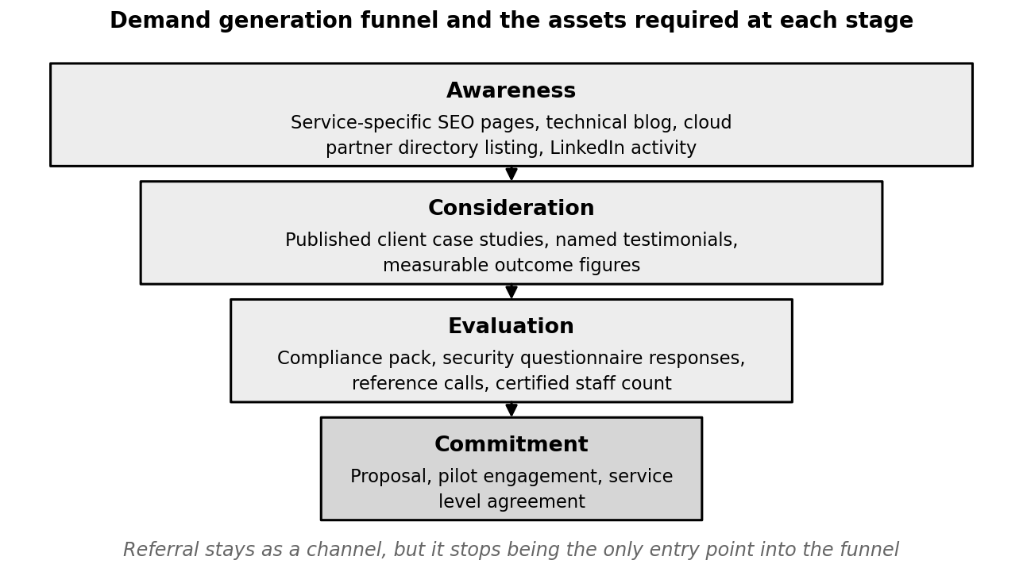
Figure 3: Demand generation funnel and the assets required at each stage

Implementation Plan
Table 9: Case Study 3 implementation plan
Action | Responsible | Timeline | Resources and technology
Launch the case-study publishing process | Division Head with marketing support | 0 to 30 days | Case study template, client sign-off process
Add testimonial capture to the project offboarding checklist | Technical Lead and project leads | 0 to 30 days | Updated project closure SOP, consent form
Publish the first six case studies from completed engagements | Division Head and project leads | Quarter 1 | Writing support, client approval
Rebuild website service pages for search visibility | External or contracted support | 30 to 90 days | Web development resource, keyword research
Start a technical blog with rotating engineering authorship | Technical Lead | From month 2, two posts a month | Editorial calendar, two hours per author per post
Apply for AWS and Azure partner tier | Division Head | 30 to 90 days, after certifications | Partner application, certified staff evidence
Pilot a second marketing channel at a regional event | Division Head | 90 days and beyond | Event budget, prepared collateral

Evaluation
By far the most revealing metric is the percentage of new clients gained through non-referral sources. It directly points to whether the growth model has been switched. Activity alone is not able to artificially inflate anything from the list below.
Monitor new client acquisition by channels quarterly. Track the proportion of referral sources rather than trying to reduce it. The idea is not to have fewer referrals but a smaller proportion reached by adding volume elsewhere. Less referral share due to less referrals is a red flag, not a good thing.
Metrics for measuring search and ranking should be taken over six to twelve month period, not one-month. Visibility changes slowly, and evaluation it too soon almost always leads to discontinuation of a method before it starts working.
Table 10: Case Study 3 key performance indicators
Indicator | Current baseline | Target
Published case studies | 2 | 8 or more within 6 months
Website and inbound share of new clients | 15 to 20 per cent | 30 per cent or more within 12 months
Referral share of new clients | 65 to 70 per cent | Below 50 per cent, without reducing referral volume
Organic search ranking for target service keywords | Not tracked | Tracked from month 1, top 20 for four terms within 12 months
Partner tier status with AWS or Azure | None | Achieved with at least one provider within 12 months
Qualified inbound enquiries per quarter | Not tracked | Tracked from month 1, rising quarter on quarter

3.4 Case Study 4: Increasing Operational Costs and Budget Management Problems

Business Needs
IM-CSS needs project-level costing and cloud spend control that can be predicted and tracked, so that adding clients does not quietly eat the margin. That means cost visibility down to the individual client, which in turn means every cloud resource has to carry a tag saying which client and which project it belongs to.
Four further things follow from that. Estimates have to be informed by what comparable work has actually cost, and not by the judgement of an engineer on the day. Each engagement needs a named person accountable for its budget. An approved ceiling has to be agreed before anybody starts work. And an alert has to fire while the spending is approaching that ceiling, rather than the overrun being discovered when the monthly bill lands.

Analysis of the Situation
Table 11: Case Study 4 baseline, twelve months to 31 July 2026
Indicator | Recorded position
Cost breakdown | Payroll 55 to 60 per cent, cloud and software licensing 20 to 25 per cent, other overhead 15 to 20 per cent (approximate)
Projects exceeding budget | Approximately 20 to 25 per cent
Two biggest cost drivers | Payroll and cloud infrastructure spend
Resource tagging by client or project | Not applied consistently
Budget alerts configured | None
Time to detect a budget overrun | Typically at month-end billing
Dedicated financial planning or FinOps capacity | None; handled informally by technical leads alongside delivery work
Related internal event | Recent internal investigation into unauthorised cloud API usage, undetected for roughly three weeks, estimated at BDT 180,000 in unplanned cost
One project in five going over the budget is a pattern and not a scoping accident. The two cost drivers named in the interview are worth keeping apart, though, because they point at two separate causes. Payroll overruns on client work usually come back to the effort being underestimated at the scoping stage, which is the ordinary failure mode of a technically-led team pricing its own work. The behaviour has a name in the forecasting literature. Kahneman and Tversky (1979) described the planning fallacy as the tendency of people estimating their own tasks to produce a figure closer to the best case than to the realistic one, even where they have direct experience of past overruns. Cloud infrastructure overruns come from somewhere completely different. They come from the resource consumption nobody is watching and nobody has budgeted for, and they surface when the invoice arrives at the end of the month.
The division's own recent investigation into unauthorised cloud API usage belongs in this section and not in a separate file marked security. The figures reported in interview make the case better than any argument about principle could. The unusual activity ran for roughly three weeks before anybody identified it, and by the time the investigation closed the episode had added an estimated BDT 180,000 in unplanned cost. Treat that as an operational estimate rather than an audited total. It still describes the control gap accurately. Nothing detected the spending. A person eventually noticed it, three weeks in, which is the exact failure mode a budget threshold or an anomaly alert exists to prevent. An alert configured at 70 per cent of a ceiling would have surfaced the same problem within days, and days of unplanned consumption cost a great deal less than three weeks of it. The wider point is that missing per-resource attribution is a financial control gap as much as a security one. Untagged spending is also the easiest kind of spending to waste. Nobody feels responsible for it, and no report ever places it next to the name of an engagement.
The structural cause is capacity, once again. Nineteen people, an administrative function that was deliberately kept lean, and no dedicated FinOps or project-costing role, so the budget is managed informally by technical leads on top of the delivery work they are already carrying. For the first two years of a division that is a fair stopgap, and it is the exact arrangement the Technical Lead described as starting to show its limits. It does not survive far past the current client count. Instead the financial risk accumulates quietly across the portfolio, because the person best placed to notice a problem is also the person with the least time available to go looking for one.
This one compounds with everything else in the report. Margin pressure eats the certification budget of Case Study 1, the monitoring platform of Case Study 2 and the compliance programme of Case Study 6, and each of those needs money that has to be found somewhere. So cost control here is not financial hygiene. It is the question of whether the division can fund the other seven recommendations at all.

Recommendation
The recommendation is a lightweight financial operations discipline sized for a nineteen-person division, following the inform, optimize and operate cycle of the FinOps Framework, shown on the right of Figure 4. The three phases run as a loop, not a line. Inform delivers cost visibility and shared accountability through allocation, budgeting and forecasting. Optimize acts on whatever that visibility exposes. Operate then turns those actions into a continuous practice, measured against indicators somebody actually tracks (FinOps Foundation, 2025). The 2025 revision of the Framework also introduced Scopes, which let a practice be applied to a defined segment of technology spending instead of the whole estate at once (FinOps Foundation, 2025). For a division of this size that is the sensible way in. The aim is not to add administrative process. It is to move the cost information out of the month-end report and into the working week.
Tagging comes first, because everything else depends on it. A mandatory standard covering client, project, environment and owner, enforced through cloud provider policy so that the untagged resource cannot be created in the first place, with the existing untagged ones cleaned up inside a quarter. Tags go on from day one of every new client environment. That becomes straightforward once the infrastructure-as-code work of Case Study 8 is running, since the template applies them automatically and, unlike a person, never forgets.
Then the cost-management tooling with alerts. AWS Cost Explorer and Microsoft Cost Management are included in the subscriptions the division already pays for, and both support budgets, threshold alerts and cost breakdowns by tag once the tagging standard is in place (Amazon Web Services, n.d.b; Microsoft, n.d.c). Every client environment then carries a monthly budget with alerts at 70 and 90 per cent of its ceiling, routed to the project lead and the Division Head at the same time. Overrun detection stops being a month-end discovery and becomes a mid-month warning. You can manage a warning. A discovery you can only report.
Third, a light FinOps review as a standing item at the project kickoff: the named cost owner, the approved budget ceiling and one mid-project checkpoint before final delivery. The cost owner should normally be the project lead and not the Division Head. Accountability has to sit with the person close enough to the work to change it.
Fourth, the historical estimation benchmark. Recording estimated against actual effort on every engagement costs a few minutes per project, and after two or three quarters it produces a correction factor that can be applied to the next round of scoping. This is reference class forecasting in miniature: the outside view, which corrects an estimate against the distribution of outcomes from comparable completed work, rather than the inside view, which builds the estimate up from the features of the task in front of you (Flyvbjerg, 2006). It is the only measure on this list that attacks the estimating half of the overrun problem instead of the spending half, and it costs nothing beyond the discipline of writing the numbers down.
And fifth, a quarterly optimisation review covering the technical measures that cut cost directly: right-sizing the instances against the utilisation actually observed, shutting non-production environments down outside working hours, moving infrequently accessed backup data into cheaper storage classes, and committing to reserved capacity where the baseline load is genuinely steady. The cost optimisation pillar of the AWS Well-Architected Framework sets out this checklist already (Amazon Web Services, 2024a), which saves the division the work of designing one of its own.
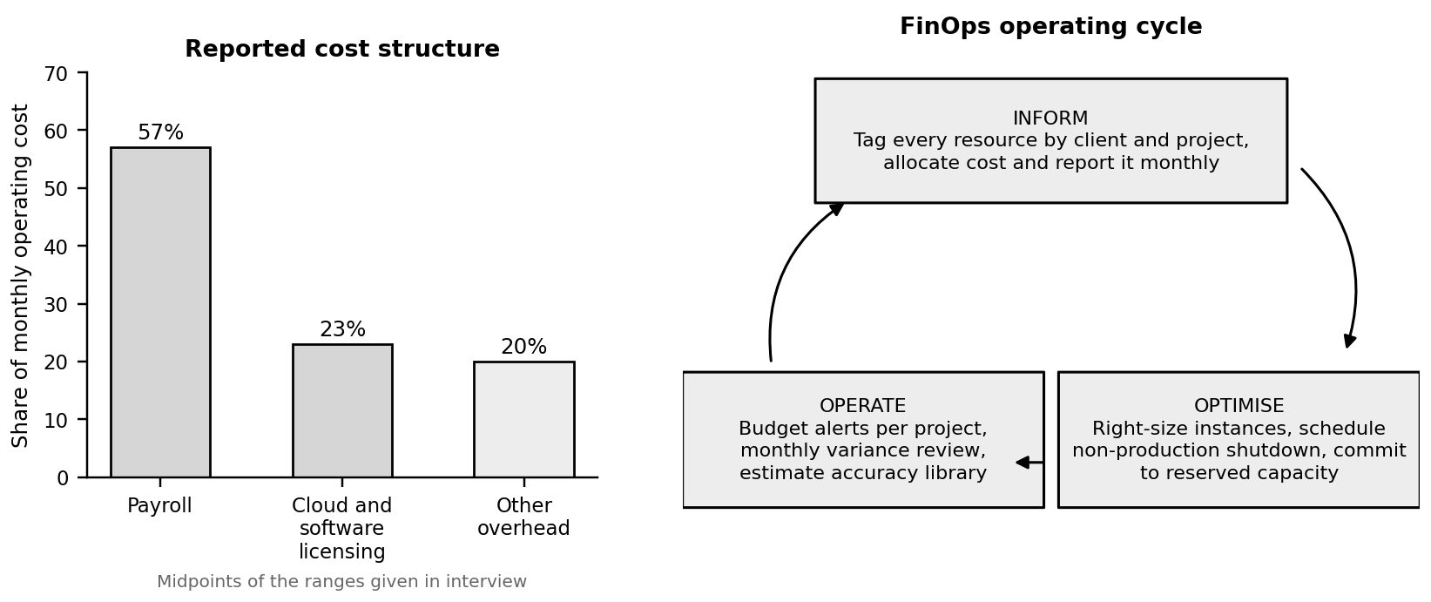
Figure 4: Reported cost structure and the FinOps cycle proposed for managing it

Implementation Plan
Table 12: Case Study 4 implementation plan
Action | Responsible | Timeline | Resources and technology
Deploy AWS Cost Explorer and Azure Cost Management with budget alerts | Sifat Ibna Amin (Technical Lead) | 0 to 30 days | Cloud provider cost tools, alert thresholds
Introduce the project cost-owner and budget-ceiling process at kickoff | Division Head | 0 to 30 days | Project kickoff checklist update
Start recording estimated against actual effort on every project | Project leads | 0 to 30 days, then continuous | Internal tracking spreadsheet or Jira fields
Define and enforce a resource tagging standard by client and project | Technical team | 30 to 90 days | Tagging policy, infrastructure-as-code template updates
Remediate existing untagged resources | Cloud engineers | 30 to 90 days | Tagging audit script, scheduled remediation
Build the historical estimation benchmark dataset | Technical Lead and project leads | 90 days and beyond | Tracking dashboard, quarterly review
Run the first quarterly cost optimisation review | Technical Lead and Division Head | End of quarter 1, then quarterly | AWS Well-Architected cost pillar checklist
Introduce monthly per-client margin reporting | Division Head with finance support | From month 3, monthly | Tagged cost data, revenue ledger

Evaluation
The percentage of projects exceeding the budget is the headline outcome and the number the Division Head should watch. It moves slowly, though, because it can only be assessed as projects finish. The faster operational reading is the time taken to detect an overrun, which ought to improve inside a single billing cycle of the alerts being switched on. It is also a fair proxy for whether the new controls are being used or only documented.
Estimate accuracy deserves a line of its own, because it changes behaviour and does not merely record it. Once the engineers can see their own historical variance written down, the estimates tend to improve without anybody intervening. Very few of the indicators in this report do any work simply by being collected. This one does.
Table 13: Case Study 4 key performance indicators
Indicator | Current baseline | Target
Projects exceeding budget | 20 to 25 per cent | Below 10 per cent
Cloud spend variance against forecast | Not tracked | Tracked monthly, within 10 per cent
Cloud resources carrying full client and project tags | Not applied consistently | 95 per cent or more within one quarter
Time to detect a budget overrun | At month-end billing | Within 48 hours of the alert threshold
Gross margin per project | Not calculated per project | Calculated monthly from month 3, improving over time
Estimate accuracy, actual against quoted effort | Not recorded | Within 15 per cent on 70 per cent of projects within 12 months

3.5 Case Study 5: Poor Client Communication and Service Reporting

Business Needs
IM-CSS needs communication that is timely, standardised and comprehensible to a stakeholder who is not technical, particularly in the stretches when something has gone wrong. That means a defined response commitment for routine queries, a written incident communication procedure setting out who tells the client what and how often, and reporting that turns up on a predictable cadence rather than when somebody remembers.
The division also needs some way of spotting dissatisfaction before it turns into a non-renewal. Client satisfaction is not formally tracked at present, so the first dependable signal that a relationship has gone wrong is the moment it ends. In a business where roughly two thirds of the new clients arrive by referral, that gap is worse than it first appears. The unhappy client does not simply stop buying. It stops recommending.

Analysis of the Situation
Table 14: Case Study 5 baseline, twelve months to 31 July 2026
Indicator | Recorded position
Typical response time to a client query | Approximately 90 minutes for non-critical issues
Status report cadence | Monthly for most clients, weekly for two larger accounts
Incident communication process | Partially standardised; a rough process exists but is not consistently followed
Post-incident reporting | Not issued as standard
Client satisfaction tracking | Not formally tracked
Named communication owner during an incident | None defined
Ninety minutes for a non-critical query is not unreasonable on its own, and taken alone it would not justify a case study. Put it next to an incident communication process that is only partly standardised, though, and the risk lands in exactly the place you would least want it. The process is least reliable at the moments when the client needs the most reassurance. The pattern is a familiar one in service teams that are growing. Routine reporting gets standardised first, because it is easy and predictable. Incident communication is harder, rarer and considerably more consequential, and so it stays informal.
The mechanism is the missing communication owner. Where there is none, the engineer performing the fix is usually also the person the client is messaging, and that arrangement serves neither job. The engineer is interrupted at the point where concentration matters most. The client receives updates whenever the engineer has a spare moment, which in practice means rarely. This runs straight into the ownership ambiguity of Case Study 7, where multi-person incident response was described in interview as getting confusing once several people are involved.
With no formal satisfaction tracking there is no early warning of a relationship deteriorating either. The dissatisfaction surfaces as a lost contract or a non-renewal, and by that point intervening is beside the point. The division also cannot say whether a departing client left over the price, the technical outcome or the communication, which makes the cause impossible to address even in hindsight.
Case Study 3 has already established how referral-dependent the growth is, which makes the consequence here worth stating bluntly. Poor incident communication does not put one account at risk. It puts at risk the referral pipeline the whole business runs on, because the client who is satisfied with the engineering but frustrated by the reporting will usually renew and quietly stop recommending. The division would experience that as a pipeline which stops filling, and would never learn why.

Recommendation
The recommendation is to treat the communication as a deliverable with an owner rather than as a by-product of the technical work. The model is taken from ITIL 4 incident management practice, which holds that target resolution times should be agreed, documented and communicated in advance so that the expectations set are realistic ones (Axelos, 2019). ITIL supplies the principle and not the numbers, however. The specific intervals proposed below are service targets this report recommends for IM-CSS, sized against the division's reported 45 to 60 minute acknowledgment time and the thirty-minute expectation described in interview, and they should be read as proposals rather than as figures carried across from a standard. Figure 5 sets out the resulting cadence.
Start with a formal incident communication protocol, with defined severity levels and a fixed update cadence attached to each of them. For IM-CSS this report proposes the following targets. A severity one incident, meaning a client service is unavailable or data is at risk, carries acknowledgment within thirty minutes, a first technical update inside the hour, rolling updates every thirty minutes until the service is restored, and a written report within forty-eight hours. Severity two carries acknowledgment within two hours and updates every four. Severity three carries acknowledgment within four business hours and one daily update. What makes these commitments achievable is the on-call rota proposed in Case Study 2, and that is the reason the two should be introduced together rather than one after the other.
Second, separate the communication owner from the engineer performing the fix. On anything above severity three, a project lead or a second engineer takes the client contact, so that the person solving the problem is left to solve it. ITIL 4 makes the same separation for major incidents, where a temporary team is assembled and stakeholder communication is handled as a distinct responsibility (Axelos, 2019). It costs nothing, it needs no tooling, and it is the single most effective item on this list.
Third, stand up a simple client-facing status page, in the same spirit as the public service health dashboards AWS and Cloudflare both operate (Amazon Web Services, n.d.d; Cloudflare, n.d.). Give the client somewhere to check the status without asking and a considerable share of the incoming queries during an incident simply stops arriving. The client who can see that a problem is known and is being worked on has no reason to send a message asking whether it is known.
Fourth, make the short post-incident summary standard practice, covering what happened, what was done about it and what prevents it happening again. At present the client gets a confirmation that the issue is fixed and nothing else. ITIL 4 treats the post-incident review as the mechanism through which incident data feeds continual improvement (Axelos, 2019), and there is a commercial effect on top of the operational one. This is where the perception of competence is actually built. A serious incident handled with a clear explanation afterwards quite often leaves the client more confident than they were before it.
And fifth, run a simple quarterly client satisfaction survey. Even the two-minute, three-question version covering responsiveness, technical quality and overall satisfaction gives the division a measurable signal on the health of a relationship, in place of nothing at all. Pair it with a structured quarterly review call for the largest accounts. That has the side benefit of surfacing exactly the case study and testimonial material Case Study 3 depends on.
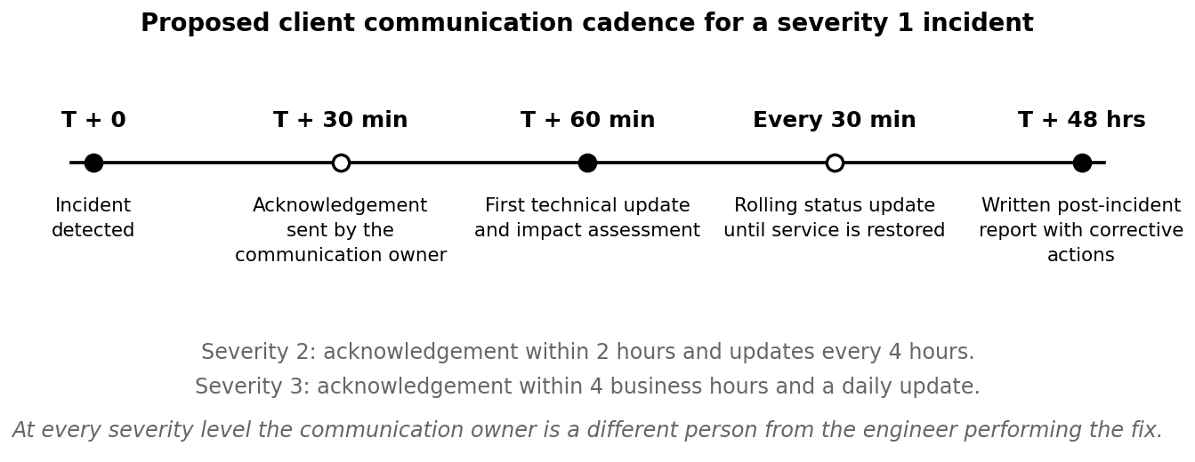
Figure 5: Proposed client communication cadence during a severity 1 incident

Implementation Plan
Table 15: Case Study 5 implementation plan
Action | Responsible | Timeline | Resources and technology
Define incident severity levels and the communication SOP | Technical Lead and Division Head | 0 to 30 days | ITIL-style incident communication template
Introduce the post-incident summary template | Sifat Ibna Amin (Technical Lead) | 0 to 30 days | Standard incident report template
Assign a communication owner separate from the responding engineer | Project leads | 0 to 30 days, then continuous | Updated incident procedure, on-call rota
Set and publish a response time commitment for routine queries | Project leads | 30 to 60 days | Revised service agreements, support workflow
Stand up the client status page | Technical team | 30 to 90 days | Status page tool such as Statuspage or Cachet
Launch the quarterly client satisfaction survey | Division Head | 30 to 90 days, then quarterly | Simple survey tool, client contact list
Introduce structured quarterly review calls for the largest accounts | Project leads | From quarter 2 | Standard review agenda and reporting pack

Evaluation
Client retention is the measure that matters financially, but it lags by a year or more, so it cannot be the only thing on the list. The satisfaction survey exists in order to provide a leading indicator. Its first contribution is also its most valuable one, and that is simply a baseline, since the division at present has no idea whether client sentiment is rising or falling.
Protocol compliance deserves a number of its own, because it is the measure most likely to slip. Written procedures decay quietly under pressure, and the incidents in which the procedure gets dropped are almost always the serious ones where it mattered. Reporting compliance monthly keeps that visible instead of allowing it to erode unnoticed.
Table 16: Case Study 5 key performance indicators
Indicator | Current baseline | Target
Average response time to a client query | Approximately 90 minutes | Under 60 minutes
Incidents following the standardised communication protocol | Partially standardised, not measured | 100 per cent from month 3
Post-incident summaries issued for severity 1 and 2 incidents | Not issued as standard | 100 per cent within 48 hours
Client satisfaction score | Not tracked | Baseline in quarter 1, improving each quarter
Client retention and renewal rate | Not formally tracked | Baseline established, then tracked annually
Complaints relating to communication during incidents | Not tracked | Tracked from month 1, trending to zero

3.6 Case Study 6: Data Privacy and Compliance Risks

Business Needs
IM-CSS holds administrative access to ten client environments and handles sensitive client data across four jurisdictions. That position carries obligations the division has not formally met. It needs standardised privacy, access-control and documentation processes fit for international clients operating under different regulatory regimes. Each of the three overseas markets has its own statutory baseline. Singapore applies the Personal Data Protection Act 2012, which imposes a set of data protection obligations including the Protection Obligation and, since the 2020 amendments, a Data Breach Notification Obligation, with financial penalties of up to ten per cent of annual turnover in Singapore (PDPC, 2021). Australia applies the Privacy Act 1988 and the Australian Privacy Principles, currently part-way through a staged programme of reform that tightens breach notification and assessment requirements (OAIC, n.d.). The United Arab Emirates applies Federal Decree-Law No. 45 of 2021 on the Protection of Personal Data, which covers consent, transparency and cross-border transfer (UAE Government, 2021). None of these regimes exempts a supplier processing data on somebody else's behalf.
It needs a documented information security management system, with written and approved policies covering access control, data handling, retention, supplier management and breach notification. Multi-factor authentication has to be enforced everywhere, with no exceptions. Access reviews have to run on a fixed schedule with recorded sign-off. And the division needs an accurate record of what client data it holds and where that data physically sits. And it needs evidence that all of this is actually happening, because a compliance framework with no evidence behind it is indistinguishable from having no framework.

Analysis of the Situation
Table 17: Case Study 6 baseline, twelve months to 31 July 2026
Indicator | Recorded position
Compliance framework followed | None formally adopted; informal alignment with general security good practice
Multi-factor authentication enforced company-wide | Partial; enforced for cloud provider accounts, not yet across all internal tools
Periodic access reviews | Informal; conducted occasionally rather than on a fixed schedule
Clients asking about compliance certifications | Yes; two clients have asked about ISO 27001 or SOC 2 status during vendor evaluation
Documented data inventory | None
Written and approved security policy set | None formally approved
Jurisdictions covered by the current client base | 4
Two clients have already asked about ISO 27001 or SOC 2 status. That is a market signal and not a hypothetical risk. IM-CSS gives up negotiating leverage by having no formal framework to point at, and it may well be losing deals invisibly, before any conversation takes place, because a recognised certification is frequently used as a shortlisting filter rather than as a discussion topic. ISO 27001 in particular functions as the procurement passport in markets where SOC 2 is less familiar, including the Middle East and much of Asia. The division would have no way of knowing when it has been filtered out.
The risk exposure is just as real. Handling sensitive client data across four jurisdictions with no adopted framework, partial multi-factor authentication coverage and informal access reviews produces a risk profile materially worse than the quality of the division's technical work would suggest. The internal cloud-security incident the team has already investigated gives that particular weight, since the threat is not theoretical here. And the wider evidence is unambiguous about which suppliers attackers prefer. The 2026 Verizon Data Breach Investigations Report found that breaches involving a third party rose by 60 per cent in a single year and now account for 48 per cent of all breaches analysed (Verizon, 2026). A managed service provider holding privileged access to ten production environments is precisely that kind of target, because compromising one provider opens the door to all of its clients at once.
Enforcing multi-factor authentication on the cloud provider accounts while leaving the internal tools uncovered is a common mistake and a poor one. The attacker who takes an internal collaboration or email account can usually reach credentials, session tokens and internal documentation from there. The uncovered tools are not a lesser risk. They are an alternative route to the same place. Since phishing and credential-stuffing attempts are already the most common attack type recorded in Case Study 2, this gap sits directly in the path of the division's most frequent threat. Verizon (2026) puts the human element in 62 per cent of breaches, which is the same category.
Informal access reviews create a related exposure. Where there is no fixed schedule, the permissions accumulate. Engineers moving between accounts retain access they no longer need, and departing staff may or may not have been fully deprovisioned, because no record exists either way. The missing data inventory compounds this. Were a breach to occur, the division could not answer the first question any regulator or client asks, which is what data was affected. Under the Singapore regime that question carries a statutory deadline attached to it, not merely a commercial one (PDPC, 2021).
So this is a growth ceiling as much as it is a risk. The larger enterprise buyers, particularly in Singapore and Australia, will frequently not shortlist a supplier that cannot show at least a documented path towards a recognised certification. The current informal approach may hold at ten clients. It becomes a hard blocker against exactly the higher-value overseas clients the division is attempting to attract in Case Study 3.

Recommendation
The recommendation is a phased programme running to certification over roughly eighteen months, with the highest-value items placed first so that the division acquires protection and credibility well before the certificate itself arrives. Figure 6 shows the sequence.
Phase one costs almost nothing and should start now. Close the multi-factor authentication gap across all internal tools and not only the cloud provider accounts, since this is low cost, high impact and aimed at the most immediate exposure. Build the data inventory, recording what client data is held, where it sits, under which jurisdiction and for how long. Put the access reviews on a fixed quarterly schedule with documented sign-off, in place of the current occasional approach, and write a joiner, mover and leaver procedure so that deprovisioning happens automatically instead of being remembered.
Phase two is the formal adoption of a recognised framework as the baseline: ISO/IEC 27001:2022 as the target, with the NIST Cybersecurity Framework 2.0 as the practical implementation reference. The two fit together rather than competing, and the 2.0 revision improves the fit, since its new Govern function and its strengthened treatment of supply chain risk address precisely the questions a client asks of a privileged supplier (NIST, 2024). Adopt the framework before chasing the certificate, so that policies and documentation exist to point at during client evaluations. A gap assessment against the Annex A controls then gives a prioritised list of what is missing. The 2022 edition of Annex A holds 93 controls arranged under four themes, those being organizational, people, physical and technological. It is a reference set and not a mandatory checklist. Which controls apply is decided by the risk assessment and recorded in a Statement of Applicability (ISO/IEC, 2022). From that list the division writes and formally approves the core policy set covering information security, access control, data retention, supplier security, incident response and business continuity. The approval step matters more than it sounds. An unapproved document satisfies neither an auditor nor, more to the point, the behaviour it is supposed to govern.
Phase three is evidence and technical control. Certification is largely a matter of demonstrating that the controls operate consistently, which in practice means logging, monitoring and recorded decisions. A useful amount of that arrives free from the SIEM platform deployed in Case Study 2. One investment, two objectives, again. Staff awareness training, supplier reviews of the division's own subprocessors, and an internal audit followed by a management review complete the preparation.
Phase four is the certification itself, through a Stage 1 documentation review followed by a Stage 2 implementation audit conducted by an accredited body, targeted inside twelve to eighteen months and treated as a client-acquisition investment rather than as a pure cost (ISO/IEC, 2022). Long before the certificate exists, though, the division should assemble a client-facing compliance one-pager and roadmap, setting out the framework adopted, the controls already in place and the certification timeline. That converts a present weakness into a visible sign of maturity which can be handed across during procurement conversations, and it recovers most of the commercial value a year ahead of the certificate. SOC 2, which reports on controls against the AICPA Trust Services Criteria rather than certifying a management system, is worth adding later if North American clients become a significant segment (AICPA & CIMA, n.d.).
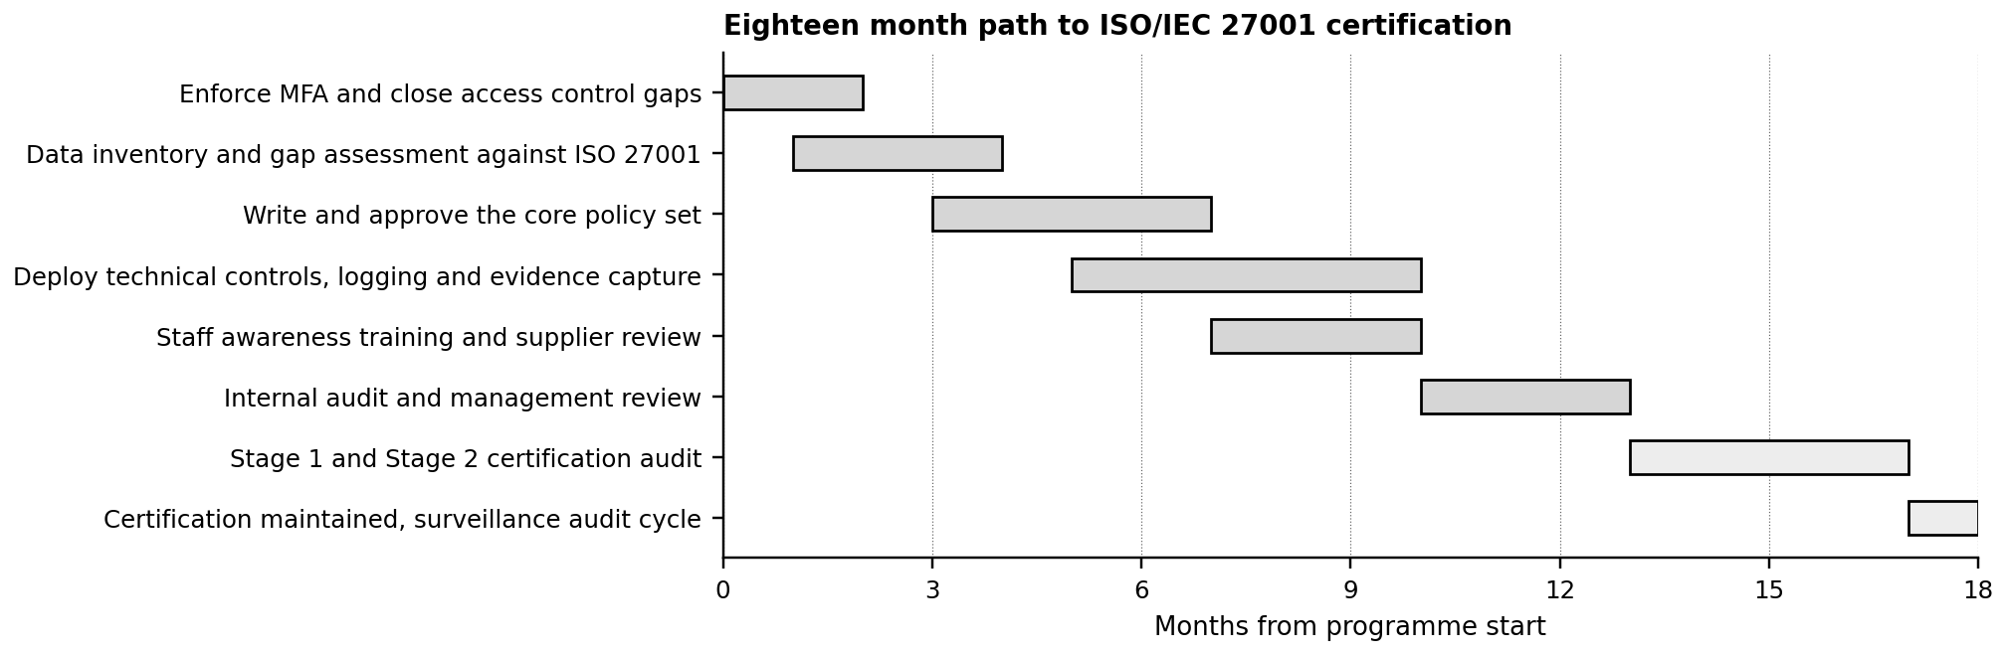
Figure 6: Phased eighteen-month path to ISO/IEC 27001 certification

Implementation Plan
Table 18: Case Study 6 implementation plan
Action | Responsible | Timeline | Resources and technology
Close the MFA gap across all internal tools | Sifat Ibna Amin (Technical Lead) | 0 to 30 days | MFA enforcement across identity provider and SaaS tools
Adopt the baseline framework and begin drafting policies | Division Head and Technical Lead | 0 to 30 days | ISO 27001 and NIST CSF documentation, policy templates
Build and maintain the client data inventory | Technical Lead and project leads | 30 to 60 days | Inventory template, per-client confirmation
Formalise the quarterly access review process | Technical Lead | 30 to 90 days, then quarterly | Access review checklist, audit log tooling
Run a gap assessment against ISO/IEC 27001 Annex A | External consultant with Technical Lead | Months 2 to 4 | Consultant engagement, control checklist
Build the client-facing compliance roadmap document | Division Head | 30 to 90 days | One-pager, sales enablement material
Approve the core policy set and deliver staff awareness training | Division Head and HR Lead | Months 4 to 9 | Approved policies, training platform
Conduct internal audit and management review | External consultant | Months 10 to 13 | Audit plan, corrective action log
Pursue formal ISO 27001 certification | Division Head with accredited auditor | 90 days and beyond, 12 to 18 month horizon | Certification body engagement, evidence pack, budget

Evaluation
This case study is unusual in that its final measure is a single binary milestone, so the interim indicators carry most of the management value. Multi-factor coverage, access review completion and policy approval are each verifiable within weeks, and each one cuts real risk immediately. That is the reason the plan front-loads them, rather than treating them as preparation for an audit more than a year away.
The commercial measure is the one that gets forgotten. Tracking how many procurement conversations were helped by the compliance evidence provided shows whether the programme is delivering the business benefit that justified it in the first place. It should begin moving from month three, when the client-facing roadmap becomes available, and that is well ahead of the certificate.
Table 19: Case Study 6 key performance indicators
Indicator | Current baseline | Target
MFA coverage across internal tools | Partial | 100 per cent within one month
Access reviews completed on schedule with sign-off | Informal and occasional | 100 per cent quarterly completion
Formal compliance framework adopted | None | Adopted within 30 days
Approved policies in the core set | None | Full core set approved by month 9
Client data inventory completeness | None | 100 per cent of active clients by month 3
Certification progress milestone | Not started | Baseline, then audit-ready, then certified within 18 months
Procurement conversations where compliance status was a positive factor | Not tracked | Tracked qualitatively from month 3

3.7 Case Study 7: Inefficient Collaboration in Remote IT Teams

Business Needs
With roughly 85 per cent of the team working remotely and clients spread across four time zones, IM-CSS needs coordination that does not depend on people being online at the same moment. Consistent tooling, clear task ownership, predictable approval turnaround across time zones.
The division also needs its decisions and approvals written down somewhere the next person can find them, instead of agreed on a call or buried in a chat thread. And it needs stated expectations about response times, so that a remote engineer knows whether waiting several hours for an answer is normal or is a problem. Ownership clarity during multi-person incident response is a requirement in its own right, because that is the situation in which ambiguity does the most damage.

Analysis of the Situation
Table 20: Case Study 7 baseline, twelve months to 31 July 2026
Indicator | Recorded position
Remote work share | Approximately 85 per cent of the team
Tools used for communication and project management | Slack, Jira and Google Workspace
Time-zone-related approval delays | Reported, particularly between Dhaka and Australia-based client coordination
Task ownership clarity | Generally clear on paper, but described as getting confusing during multi-person incident response or when several people touch the same client account
Written decision record | No formal decision log
Documented response time expectations | None
The tooling is not the problem here. Slack, Jira and Google Workspace are a perfectly sensible stack for a division of this size, and adding another tool would make the situation worse rather than better. What is missing is the process discipline that has to sit on top of them. Both of the reported symptoms, the time-zone approval delays and the ownership confusion, trace back to the same gap. There is no explicit decision-rights framework layered over the tools. Nobody has written down who decides what.
The pattern is a very common one in small remote teams that scale quickly. Informal coordination, in which you simply ask whoever happens to be around, works well enough at five to ten people. It falls apart once the team crosses into double digits and spans several time zones, which is precisely where IM-CSS sits now, at nineteen people across four client regions.
The Dhaka to Australia approval friction deserves particular attention, because Australia is an active client region and not an internal convenience. Figure 7 shows why the problem concentrates there. Dhaka working hours overlap comfortably with Bangladesh, Singapore and the United Arab Emirates, but the overlap with Australian business hours is roughly three hours at the top of the Dhaka day. That is enough to run a business on, and a good many distributed companies manage with less, but only where the approvals are handled asynchronously. The delay occurs because approvals are currently treated as synchronous events, with somebody waiting for a call or for the other person to appear in Slack, when a written approval left in Jira the previous evening would have been picked up first thing. So this is not only an internal inefficiency. It turns into client-visible delay every time Australian work needs Dhaka-side sign-off.
One case described in the interview shows what that costs in practice. A routine client approval needing input from the Dhaka team was raised after the overlap window with Australia had closed for the day. It then sat for roughly eighteen hours before the responsible person was free to look at it, and the next stage of the work slipped by close to a full business day. Nothing about the decision was difficult. No technical problem was involved. The delay came entirely from two people being online at different hours with no agreed way of passing an approval across the gap in writing. That is the whole argument for what follows. A written decision carrying an explicit deadline costs nothing and removes this category of delay outright. Waiting for the right person to appear in Slack removes nothing at all.
The ownership confusion during multi-person incident response is the more urgent version of the same problem, because it compounds the communication gap of Case Study 5 directly. Where nobody is clearly leading the response, nobody clearly owns the job of telling the client what is happening. The two failures then feed each other at exactly the moment when both matter most.

Recommendation
The recommendation is explicit coordination practice rather than new tools, designed around the overlap windows that genuinely exist instead of pretending the team is in one room.
Start with a RACI matrix for the recurring workflows: client onboarding, incident response, change approval, project delivery milestones and monthly reporting. Each workflow gets a named responsible party, one accountable owner, the people to be consulted and the people to be informed. The RACI chart is the common form of the responsibility assignment matrix described in the PMBOK Guide, where its purpose is to make sure each work package has one unambiguous owner (Project Management Institute, 2021). It is roughly a two-hour exercise for each workflow and it removes an entire category of delay permanently. Almost all of its value comes from being written down and visible, and almost none of it from sophistication in the analysis.
Second, adopt asynchronous-first documentation norms for the decisions and the approvals. Any approval that does not require live discussion is requested and granted in writing in Jira or Confluence with a stated deadline, and any decision taken on a call is logged in writing the same day. The test is simple enough. An engineer starting the day in Dhaka should be able to establish what was decided overnight without messaging anybody, and the Australia-based counterpart should be able to collect a written approval left the evening before without needing a meeting.
Third, designate a rotating incident commander for multi-person incident response specifically. On any incident involving more than two people, one named person leads and coordinates rather than performing technical work. ITIL 4 anticipates this arrangement, describing complex and major incidents as requiring a temporary team drawn from several stakeholders and managed as a unit (Axelos, 2019). The role pairs with the communication owner of Case Study 5, and between them the two close the ownership gap at the point where it does the most damage.
Fourth, set explicit asynchronous response-time norms. Non-urgent Slack messages answered inside four business hours, written approvals inside one business day, and anything genuinely urgent routed through the incident escalation path of Case Study 2 instead. The point is to remove the ambiguity. A remote team member who does not know what is expected will either interrupt colleagues unnecessarily or wait far too long. Both are avoidable.
And fifth, a written end-of-day handover for the accounts that cross time zones, the Australian ones above all. A short standard note covering what was done, what remains outstanding and what needs a decision converts that narrow overlap window from a bottleneck into a handover point.
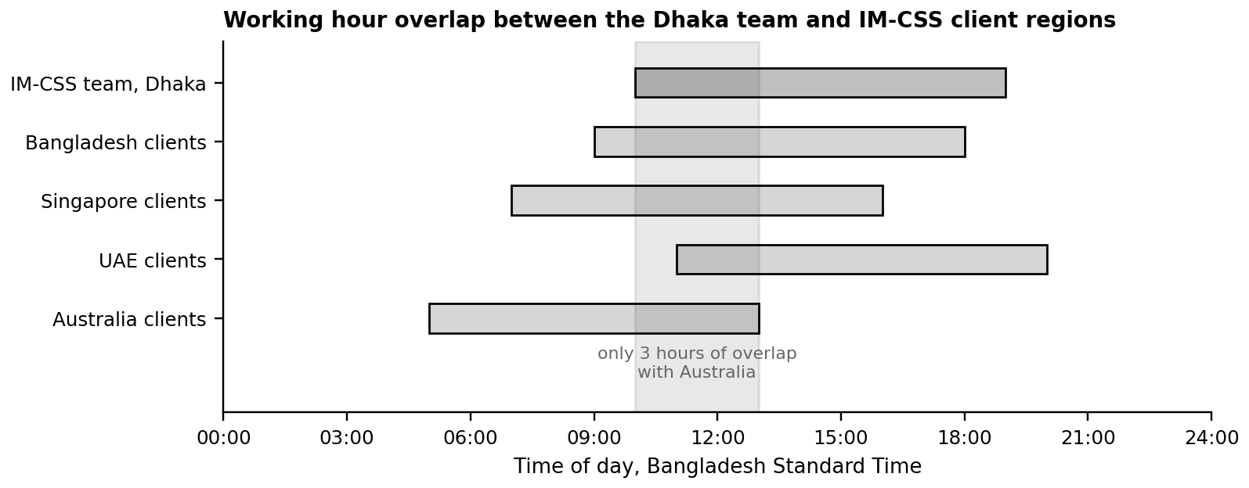
Figure 7: Working hour overlap between the Dhaka team and IM-CSS client regions

Implementation Plan
Table 21: Case Study 7 implementation plan
Action | Responsible | Timeline | Resources and technology
Build a RACI matrix for the core recurring workflows | Technical Lead and Division Head | 0 to 30 days | RACI template, workflow documentation
Establish the async decision-log norm in Jira and Confluence | Technical team | 0 to 30 days | Confluence or Jira documentation space
Publish response time norms for internal communication | Technical Lead | 0 to 30 days | Internal communication policy
Define and staff the rotating incident commander role | Sifat Ibna Amin (Technical Lead) | 30 to 90 days | Incident response SOP update, rota
Introduce a written end-of-day handover for cross-time-zone accounts | Project leads | 30 to 60 days, then daily | Standard handover format in Jira
Move approvals to written asynchronous form with stated deadlines | Project leads | 30 to 90 days, then continuous | Jira approval workflow
Run a quarterly internal pulse survey on clarity and coordination | HR Lead | End of quarter 1, then quarterly | Short internal survey

Evaluation
Approval turnaround is the most useful single measure. It is objective, it can be pulled out of Jira with no additional effort once the approvals live there, and it responds quickly when the practice changes. The first job is simply to measure it at all. The division knows the delay exists but has never put a number against it.
Ownership clarity is what ties this case study to the others. The ambiguity is what produces the silence towards clients during incidents and the duplicated effort during onboarding, so an improvement here ought to appear in the Case Study 5 and Case Study 8 indicators as well. Where it does not, the RACI matrices are being kept on paper and not in practice, and the post-incident retrospective is where that becomes obvious.
Table 22: Case Study 7 key performance indicators
Indicator | Current baseline | Target
Average approval turnaround across time zones | Reported as delayed, not measured | Baseline in month 1, then measurably reduced
Recurring workflows with a documented RACI | None | 100 per cent of core workflows within 2 months
Incident response ownership clarity | Described as confusing with multiple responders | Tracked via post-incident retrospective feedback
Decisions recorded in the written decision log | None | 100 per cent of workflow decisions from month 2
Team-reported clarity on task ownership | Not measured | Baseline via pulse survey in quarter 1, improving each quarter
Cross-time-zone accounts with a daily written handover | None | 100 per cent within 60 days

3.8 Case Study 8: Challenges in Scaling Infrastructure and Business Operations

Business Needs
IM-CSS needs automated, repeatable infrastructure provisioning and a standardised client onboarding process, so it can take on more clients without a matching increase in manual effort. Environment builds should be an execution task rather than a design task, and the sequence should be identical every time so that someone other than the division's most senior engineers can follow it.
It also needs a service structure that stops treating every client as bespoke, since designing from scratch for a straightforward client burns the same senior hours as designing for a complex one. And it needs the senior staff off the critical path of every new environment, both because they are the constraint on growth and because they are the same people Case Study 1 identified as the hardest to replace.

Analysis of the Situation
Table 23: Case Study 8 baseline, twelve months to 31 July 2026
Indicator | Recorded position
Client onboarding time | Approximately 5 to 7 days
Concurrent projects currently supportable | Approximately 6 to 8
Infrastructure and deployment automation level | Partially automated
Biggest bottleneck when a large new client signs on | Manual provisioning steps and limited senior staff availability to oversee new environment setup
Technical headcount available for delivery | 13
Standardised onboarding runbook | Not documented as a single standard
Five to seven days to onboard, a ceiling of roughly six to eight concurrent projects, thirteen technical staff. Put those three figures together and IM-CSS is already close to its practical capacity limit under the current partially automated model. The division is not far from the point at which taking on a new client means degrading the service given to an existing one. That is a growth constraint stated in concrete operational terms and not as a general worry.
The bottleneck named in the interview is really two constraints compounding. The automation exists, but not consistently enough to remove senior staff from the critical path, so growth is limited by the availability of the same small group of experienced people flagged as a retention risk in Case Study 1. Case Study 1 and Case Study 8 are therefore not independent problems. The infrastructure bottleneck makes the division more dependent on its scarcest people, and that dependency in turn raises the business impact should one of them leave. Automating the provisioning buys more than efficiency, then. It also cuts the key-person dependency.
Manual provisioning carries a quality cost on top of the speed cost. Environments built by hand differ from one another in small ways, and the differences accumulate until an environment no longer matches what anybody believes it to be. Configuration drift of that kind consumes analyst attention in Case Study 2 and generates client communication in Case Study 5. The true cost of manual provisioning is therefore spread across several parts of the division, and it is consistently underestimated whenever it is examined in isolation.
There is a commercial angle to it as well. Because every client is effectively treated as bespoke, the senior design effort goes into engagements which do not require it. The client with a standard application and routine backup requirements receives the same custom attention as the complex one. That is expensive for IM-CSS, and it is not something the smaller client is paying for. It feeds straight into the margin pressure documented in Case Study 4, and it is the reason a tiered service model appears in the recommendation below alongside the technical change.

Recommendation
The recommendation is to turn environment provisioning from a design activity into a repeatable manufacturing one, using infrastructure as code and a tiered service catalogue. Figure 8 shows the target model.
At the core of it is infrastructure as code for all new client environments, using Terraform, with CloudFormation available as the AWS-native alternative where a client's requirements make that preferable. Terraform describes infrastructure declaratively and reconciles the running environment against that declaration, which is what makes the drift described above detectable rather than merely regrettable (HashiCorp, n.d.). A reusable module library should cover the patterns IM-CSS actually deploys: network segmentation, the identity and access baseline, encryption defaults, logging and monitoring agents, backup policy and cost tags. A new client environment then becomes a configuration file full of variables instead of a fresh build. And because every change passes through version control with peer review, the environment definition ends up documented by construction, rather than by somebody remembering to write it up afterwards.
Wrapped around that library is a validation pipeline that checks every change before it is applied. Policy checks reject a non-compliant configuration automatically. Security scanning runs alongside them. Cost estimation makes the financial consequence of a change visible before deployment instead of at month end. This connects straight back to the tagging work of Case Study 4, since tags applied by the module library go on consistently and cannot be forgotten.
The environments themselves belong in a multi-account structure, with one account per client for isolation, plus shared accounts for security logging and for backup and recovery. The pattern is established in the guidance of both providers. AWS Control Tower provisions and governs a multi-account environment with guardrails applied centrally (Amazon Web Services, n.d.c), and the Azure landing zone architecture in the Microsoft Cloud Adoption Framework does the equivalent for Azure subscriptions (Microsoft, n.d.d). Taking the standard structure instead of inventing one carries the additional benefit of satisfying the isolation expectations that appear in client security questionnaires, and in the compliance work described in Case Study 6.
Alongside the technical change, the division should build a standardised client onboarding template and runbook, so that the five to seven day timeline becomes consistent and largely execution-only rather than requiring senior judgement calls at every new client. It should also introduce a tiered service model: the standard package, provisioned directly from the template, and the premium package, which adds bespoke design work by a senior engineer and is priced accordingly. This is the change that genuinely removes senior staff from the critical path, because most engagements stop needing them at all. It also lets the division charge honestly for bespoke work instead of absorbing the cost of it.
Finally, the infrastructure and the operational practice should be lined up against the six pillars of the AWS Well-Architected Framework, those being operational excellence, security, reliability, performance efficiency, cost optimization and sustainability, the last of which was added in 2021 (Amazon Web Services, 2024a). Used as a structured maturity benchmark it beats an ad hoc review. Running a Well-Architected review against the two largest client environments in the first quarter would establish a baseline to measure improvement against. The AWS Well-Architected Tool itself is free to use.
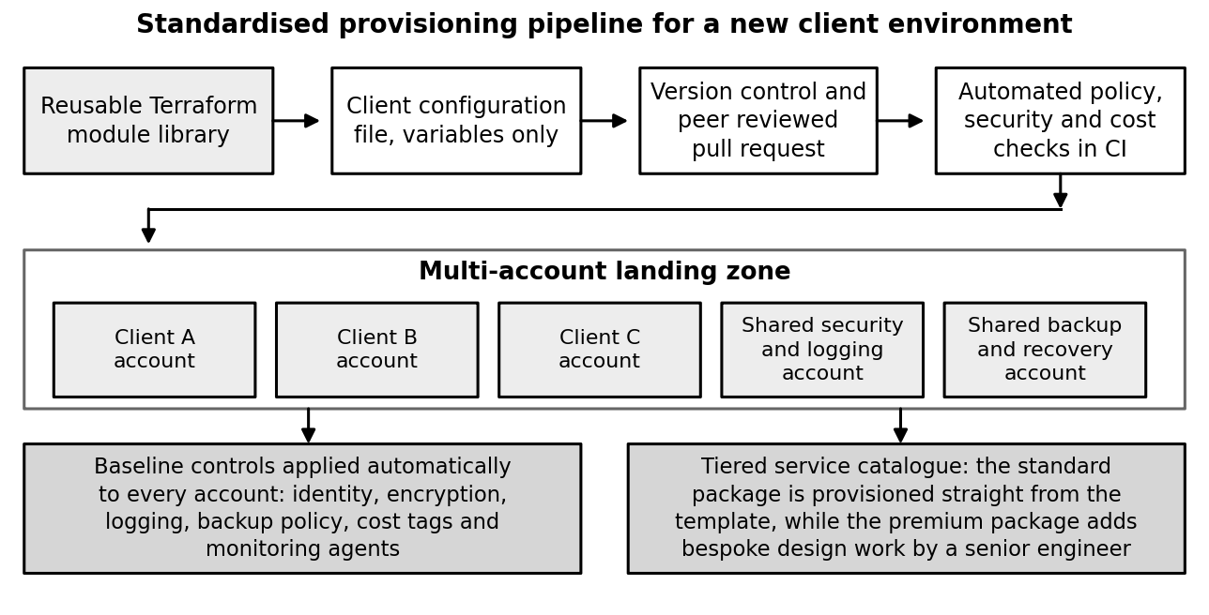
Figure 8: Standardised provisioning pipeline and multi-account structure

Implementation Plan
Table 24: Case Study 8 implementation plan
Action | Responsible | Timeline | Resources and technology
Build Terraform IaC templates for standard client environments | Sifat Ibna Amin (Technical Lead) | 0 to 30 days | Terraform, existing AWS and Azure environments as reference
Set up the validation pipeline with policy, security and cost checks | Cloud and DevOps engineers | 30 to 90 days | CI platform, policy-as-code tooling
Adopt the AWS Well-Architected review checklist | Technical team | 30 to 90 days | AWS Well-Architected Tool, internal review process
Build the standardised onboarding runbook | Technical Lead and project leads | 30 to 90 days | Documented runbook, checklist tooling
Implement the multi-account structure for client isolation | Technical Lead and cloud engineers | Quarter 2 | AWS Control Tower or Azure Landing Zones
Migrate the two largest client environments to infrastructure as code | Cloud engineers | Quarter 2 | Terraform import, change windows agreed with clients
Design and price the tiered service packages | Division Head | 90 days and beyond | Service catalogue, pricing model update
Migrate remaining client environments to infrastructure as code | Cloud engineers | Quarters 3 and 4 | Terraform modules, scheduled migration windows

Evaluation
Onboarding time is the headline measure, because it is the thing the client experiences directly and the thing that caps growth. Cutting it from five to seven days down to two or three for the standard engagements would roughly double the number of clients the division could absorb in a year without hiring anybody at all. That is the whole commercial argument for this programme.
The number of senior engineers required on the critical path is what captures the risk reduction, and it deserves separate reporting for that reason. Taking it to zero for the standard onboarding means growth is no longer hostage to whether two or three individuals happen to be available. That matters as much for continuity as it does for speed.
The Well-Architected review score is the quality measure, and it should be tracked across successive reviews rather than read as a single result, because the value of it sits in the trend. A score which climbs across three consecutive reviews is evidence that the standardisation is real and not nominal.
Table 25: Case Study 8 key performance indicators
Indicator | Current baseline | Target
Client onboarding time | 5 to 7 days | 2 to 3 days for the standard tier
Concurrent projects supportable without a senior-staff bottleneck | 6 to 8 | 12 or more without additional senior hires
Infrastructure provisioning that is fully automated | Partial | Full for the standard tier within 12 months
Client environments defined as code | Partial | All 10 within 12 months
Senior engineers required on the critical path for a standard onboarding | Senior oversight required for every environment | Zero for the standard tier
Well-Architected review score | Not measured | Baseline in quarter 1, improving at each successive review

4. Strategic Recommendations Summary
Taken one at a time, the eight case studies describe eight problems. Taken together they describe one problem appearing in eight places: a division whose management systems were built for a small team and are now being asked to run a business of nineteen people serving ten clients across four time zones. The framing matters, because it changes what the sequencing ought to look like. Figure 9 shows how the challenges connect.
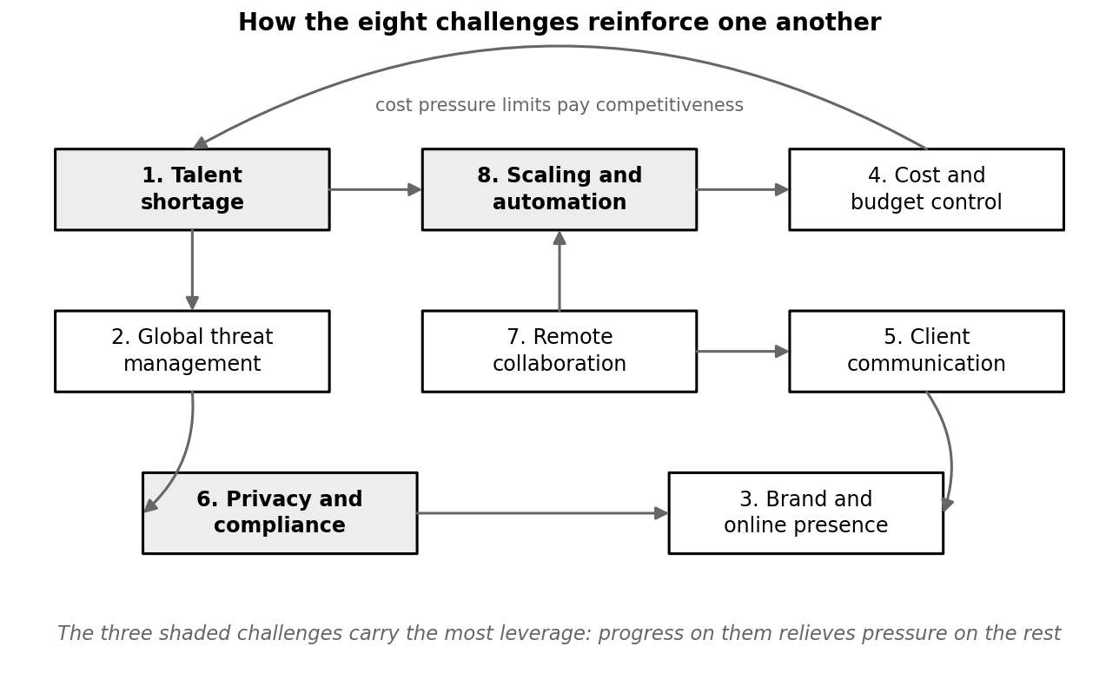
Figure 9: Relationships between the eight challenges
Three of them carry more weight than the rest. The talent shortage of Case Study 1 and the scaling constraint of Case Study 8 feed each other directly, since manual provisioning makes the division dependent on its most senior engineers, and that dependency makes losing any one of them far more damaging. Automating the provisioning therefore does two jobs in a single movement. It eases the growth constraint and it cuts the key-person risk. The compliance programme of Case Study 6 is the third. It guards against the risk the division is most exposed to as a privileged supplier, a category of breach that grew by 60 per cent in one year and now features in 48 per cent of the breaches Verizon analysed (Verizon, 2026). It also removes the procurement filter currently keeping IM-CSS out of exactly the deals it wants to win.
A second theme is that automation substitutes for the headcount the division cannot easily hire. Infrastructure as code in Case Study 8, SIEM correlation and automated alert triage in Case Study 2, cloud cost-monitoring tooling in Case Study 4. Every one of them reduces dependence on the same small pool of senior technical staff, and so every one of them mitigates the retention risk identified in Case Study 1. This also aligns with where the profession itself has moved. ISC2 (2025) reported that practitioners now rank the shortage of specific skills above the shortage of people, which is a different problem and has a different remedy. For an organisation that cannot win a salary contest against the multinationals, buying senior engineering hours back through automation is the more reliable strategy.
A third theme is formalisation in place of improvisation, and what is striking is how little most of it costs. Incident communication in Case Study 5, the compliance framework in Case Study 6, workflow ownership in Case Study 7. Each is handled informally at present, or only partly. Turning each into a documented, repeatable process is far cheaper than it looks, and it compounds into credibility with international clients. What these changes have in common is that they exchange improvisation for a written standard. And the reason none of them has happened yet is not cost. It is ownership. Each one is currently somebody's second job.
A fourth theme is that credibility, and not capability, is the binding constraint on growth. The division delivers well enough that around two thirds of its new clients arrive by referral, and it is nonetheless filtered out of vendor evaluations for want of a certification and passed over in search results for want of a visible track record. The published case studies of Case Study 3 and the formal certification of Case Study 6 both perform the same conversion. They turn quality work which already exists into proof that somebody else can see. The absence of that proof is what caps the value of the contracts IM-CSS can realistically bid for.
The last theme is interdependency, and it is the reason the sequencing matters more than tackling each challenge on its own. The talent shortage and the scaling bottleneck reinforce one another. The branding gap and the communication gap threaten the same referral-dependent growth engine. And the cost pressure of Case Study 4 limits the division's ability to fund any of the rest. Work through them in the wrong order and you spend money the division does not have yet, on problems which would have been easier to solve later.
Since the division cannot run eight programmes at once with nineteen people and a lean administrative function, the sequence below puts the cheap, the quick and the unblocking work first.
Table 26: Suggested sequencing of the eighteen-month programme
Phase | Work in this phase | Why it sits here
0 to 30 days | Close the MFA gap; document incident severity levels and the communication SOP; adopt a baseline compliance framework; configure cloud budget alerts; publish the career ladder; launch the certification budget; begin the case-study process; build RACI matrices; start Terraform templates | Low cost, fast to implement, and each item either reduces an active risk or unblocks later work
30 to 90 days | Deploy the SIEM platform across client environments; run the ISO 27001 gap assessment; enforce resource tagging; build the on-call rota; rebuild website service pages; stand up the status page; build the onboarding runbook | The main investments, sequenced so that the monitoring platform serves both the security and compliance objectives
Quarter 2 to month 12 | Complete the infrastructure-as-code migration; apply for AWS and Azure partner tier; approve the policy set; implement the multi-account structure; launch the satisfaction survey; introduce tiered service packages; recruit the first graduate trainee cohort | Growth-enabling work that depends on the foundations laid in the first two phases
Months 12 to 18 | Internal audit and ISO 27001 certification; regional event presence; second Well-Architected review; retention incentive rollout; second trainee cohort | Consolidation, external validation, and the shift from fixing problems to compounding advantages

5. Conclusion
IM-CSS is not a struggling business. The interview data describes a team that resolves its incidents, keeps its clients and grows mostly through referral, and all three are signs of genuine service quality rather than of a division in difficulty. The eight challenges documented here are the predictable growing pains of a technically strong team scaling past the point at which informal process is sufficient. As problems go, that is a considerably better one to have than the alternative.
What the analysis does show is that the informal period is over. Fifteen per cent turnover against thirteen technical staff. A 45 to 60 minute acknowledgment time. One project in five exceeding its budget, two clients asking about certifications the division does not hold, a concurrent project ceiling of six to eight. These are not independent pieces of bad luck. They are what happens when a division adds clients faster than it adds the systems required to serve them, and they will go on compounding until the systems catch up.
The encouraging part is how much of the remedy is cheap. The changes with the highest immediate return are mostly a matter of writing something down and then giving it an owner: the severity levels, the communication cadence, the tagging rules, the quarterly access reviews, the published pay bands, the ownership matrices. The genuinely expensive items, meaning the SIEM platform, the certification programme and the infrastructure-as-code migration, are investments with identifiable returns rather than overheads. Each of them also relieves more than one of the eight problems at once.
If IM-CSS management took only three things from this report, they should be these. Close the multi-factor authentication and compliance gap, because it protects the division against its largest real exposure and lifts the filter which currently keeps it away from higher-value clients. Automate the provisioning, because it raises the growth ceiling and reduces the key-person risk at the same time. And formalise the incident communication, because it protects the referral pipeline the entire business runs on. Doing those three would meaningfully de-risk the division while serving its stated goal of winning larger international clients directly, and it would leave the remaining five challenges looking a good deal more manageable than they do today.

6. References
AICPA & CIMA. (n.d.). SOC 2: SOC for Service Organizations, Trust Services Criteria. Association of International Certified Professional Accountants. https://www.aicpa-cima.com/
Amazon Web Services. (n.d.a). AWS Services Partner tiers and AWS Partner Network. https://aws.amazon.com/partners/services-tiers
Amazon Web Services. (n.d.b). AWS Cost Explorer and AWS Cost Management. https://aws.amazon.com/aws-cost-management/aws-cost-explorer/
Amazon Web Services. (n.d.c). AWS Control Tower: multi-account environment governance. https://aws.amazon.com/controltower/
Amazon Web Services. (n.d.d). AWS Health Dashboard: service health. https://health.aws.amazon.com/health/status
Amazon Web Services. (2024a). AWS Well-Architected Framework: operational excellence, security, reliability, performance efficiency, cost optimization and sustainability pillars (rev. 6 November 2024). https://aws.amazon.com/architecture/well-architected/
Axelos. (2019). ITIL 4: Incident Management Practice Guide. Axelos Limited. https://www.axelos.com/certifications/itil-service-management
Cisco Talos. (n.d.). Cisco Talos Intelligence Group: threat intelligence and research. https://talosintelligence.com/
Cloud Security Alliance. (2017). Security Guidance for Critical Areas of Focus in Cloud Computing v4.0. https://cloudsecurityalliance.org/research/guidance
Cloudflare. (n.d.). Cloudflare application security: WAF, DDoS protection and bot management. https://www.cloudflare.com/
FinOps Foundation. (2025). The FinOps Framework: phases, domains, capabilities and scopes (Framework 2025 update). Linux Foundation. https://www.finops.org/framework/
Flyvbjerg, B. (2006). From Nobel Prize to project management: Getting risks right. Project Management Journal, 37(3), 5-15.
HashiCorp. (n.d.). What is Terraform? Infrastructure as code. https://developer.hashicorp.com/terraform/intro
ISC2. (2025). 2025 ISC2 Cybersecurity Workforce Study. International Information System Security Certification Consortium. https://www.isc2.org/Insights/2025/12/2025-ISC2-Cybersecurity-Workforce-Study
ISO/IEC. (2022). ISO/IEC 27001:2022. Information security, cybersecurity and privacy protection. Information security management systems, requirements. International Organization for Standardization. https://www.iso.org/standard/27001
Kahneman, D., & Tversky, A. (1979). Intuitive prediction: Biases and corrective procedures. TIMS Studies in Management Science, 12, 313-327.
Microsoft. (n.d.a). Microsoft Sentinel: cloud-native security information and event management. https://azure.microsoft.com/en-us/products/microsoft-sentinel/
Microsoft. (n.d.b). Microsoft Partner Network and customer stories. https://partner.microsoft.com/
Microsoft. (n.d.c). Microsoft Cost Management and Billing. https://azure.microsoft.com/en-us/products/cost-management/
Microsoft. (n.d.d). Cloud Adoption Framework for Azure: Azure landing zones. https://learn.microsoft.com/en-us/azure/cloud-adoption-framework/ready/landing-zone/
NIST. (2024). The NIST Cybersecurity Framework (CSF) 2.0 (NIST CSWP 29). National Institute of Standards and Technology. https://doi.org/10.6028/NIST.CSWP.29
OAIC. (n.d.). The Privacy Act 1988 and the Australian Privacy Principles. Office of the Australian Information Commissioner. https://www.oaic.gov.au/privacy/australian-privacy-principles
PDPC. (2021). Personal Data Protection Act 2012 and Advisory Guidelines. Personal Data Protection Commission Singapore. https://www.pdpc.gov.sg/
Project Management Institute. (2021). A guide to the project management body of knowledge (PMBOK guide) (7th ed.), Section 1.2.6.1: Project business case. Project Management Institute.
Stamus Networks. (2025). Findings of the 2025 SANS Detection and Response Survey: false positives and alert fatigue. https://www.stamus-networks.com/blog/what-the-2025-sans-detection-response-survey-reveals-false-positives-alert-fatigue-are-worsening
Tariq, S., et al. (2025). Alert fatigue in security operations centres: Research challenges and opportunities. ACM Computing Surveys. https://doi.org/10.1145/3723158
UAE Government. (2021). Federal Decree-Law No. 45 of 2021 on the Protection of Personal Data. https://u.ae/en/about-the-uae/digital-uae/data/data-protection-laws
Verizon. (2026). 2026 Data Breach Investigations Report (19th ed.). Verizon Business. https://www.verizon.com/business/resources/reports/dbir/
Primary source: structured interview with Sifat Ibna Amin, Senior Technical Lead, Intelligent Machines Cloud and Security Solutions, Banani, Dhaka, conducted August 2026.

